**Easy Keto Dessert Recipes.**  
We all know that sugar cravings are one of the most unstoppable needs. No matter how far we have come in our weight loss or on your fitness journey, it is just not possible to replace our sugar cravings. When it comes to dessert, every human gets melted with the smell of hot chocolate or a freshly baked cake. It is not easy to ignore the tastiest and delicious smell of any desert. Whether it is an ice cream craving at midnight or having early morning hot chocolate, getting fit is equally necessary, and sugar is one of the enemies when it comes to having a fitness journey going on.  
 It is not easy to blame people for letting us have sugar cravings, especially when we are on a diet, and our family or friends have desires in front of us, but all we can do is just ignore our cravings. But the Keto diet is one of the most effective foods.

Many human beings have tried and tested a keto diet. One who wants faster results of weight loss should try the Keto diet. And if you are already doing Keto diet, then you can easily follow these easy **Keto dessert recipes**, which will help you to solve your sugar cravings. Make sure that these recipes are to solve your dessert cravings. It won't get affected in your calorie count. These below mentioned **keto dessert Recipes** are worth trying.  
 **1. Always hot chocolate first**  
 We all know how much we love having hot chocolate as we can have it in many seasons. And winters are just meant for having hot chocolate all day. This is one of the best **keto dessert recipes**. All you have to do is get unsweetened cocoa powder, keto-friendly sugar, water, heavy cream, vanilla extract, and some whipped cream. Mix everything well as directed on medium heat. You can easily have your hot chocolate, which doesn't even have many calories.  
Credits: <https://www.delish.com/cooking/g4803/keto-desserts/?slide=31> **2. Pumpkin Cheesecake**  
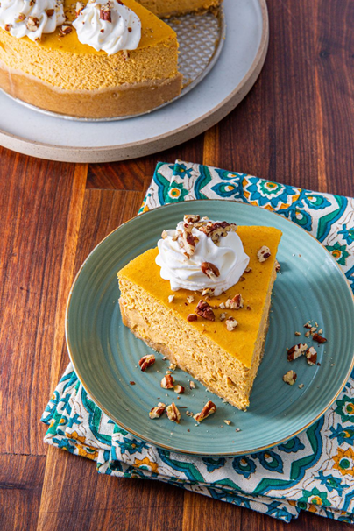  
Who knew a pumpkin cheesecake could be eaten in your weight loss. Now you can add it in your best **keto Dessert Recipes**. All you have to do is get necessary cheesecake materials; You must add almond flour, coconut flour, pumpkin purée, few eggs, vanilla extract, and also some soft and cream cheese. You can add your favorite nuts. Rest all necessary ingredients as directed. Make sure you make the tastiest cheesecake.  
Credits: <https://www.delish.com/cooking/g4803/keto-desserts/?slide=31>  
**3. Yes, a chocolate cake!**  
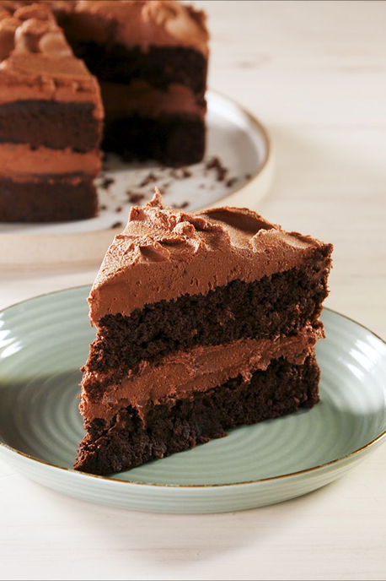When it comes to having a chocolate cake, we all know that consuming 500 calories is going to be not healthy if we have a weight loss diet. But now, when it comes to **keto dessert Recipes**, we can easily make a keto chocolate cake. All you have to do is replace your all-purpose flour with almond flour, coconut flour and have essential baking ingredients. Also, use keto-friendly sugar, and you can add brewed coffee to enhance the taste of the chocolate cake.  
Credits: <https://www.delish.com/cooking/g4803/keto-desserts/?slide=31>  
**4. Chocolate Chip Cookies**  
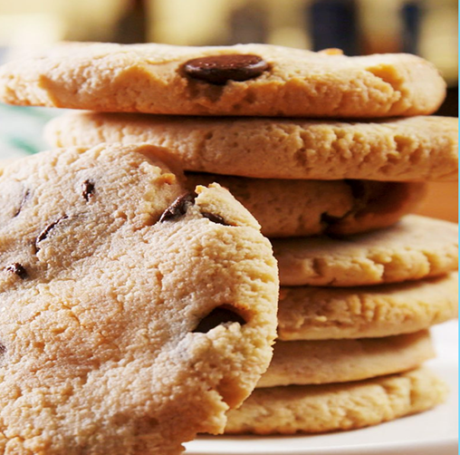 Chocolate chip cookies are one of the most favorite desserts for every human being. It is counted as one of the most wanted **Keto dessert recipes**. Now you can make chocolate chip cookies at home, which is entirely not crossing your calorie count. You can add almond flour, Keto-friendly sugar, dark chocolate chips, and essential baking ingredients or as directed. It will be completely sugar-free, a low-carb dessert.  
  
**5. Sugar-Free Cheesecake**  
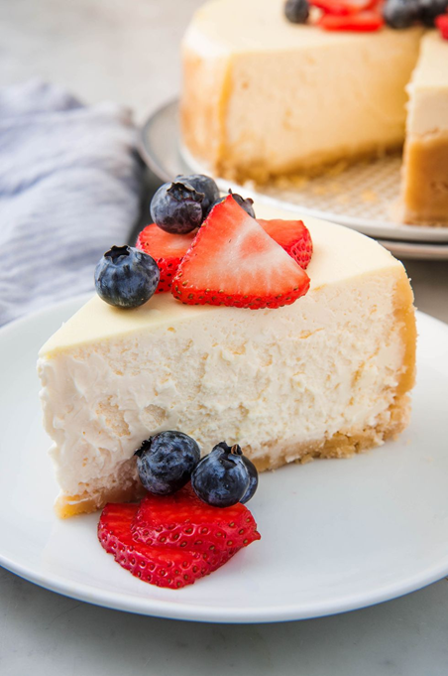  
Cheesecake is always one of the best moods. When it comes to trying **keto dessert Recipes**, cheesecake is a must. As sugar is the enemy in our diet, so making it sugarless can be much more innovative. It is easy to make, and it can be quickly be eaten too.

By adding flour, coconut flour, shredded coconut, and blocks of cream cheese, Vanilla extract, and some eggs, you can garnish it with your favorite fruits and make it healthier. You are love cheesecakes, and now even people who are on a keto diet can have it.  
Credits: <https://www.delish.com/cooking/g4803/keto-desserts/?slide=31>

. **6. Creamy and delicious Ice cream!**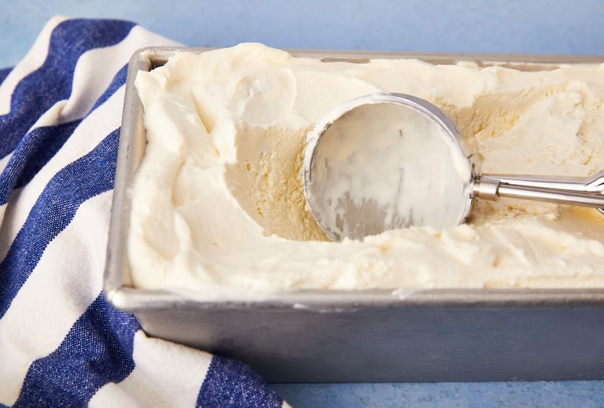 We all know that ice cream cravings are one of the most unbearable needs. But when it comes to having one of the best deserts, this is of the most recommended **keto Dessert Recipes**. By adding coconut milk, heavy cream, Quito friendly sweetener, and vanilla extract, you can easily make keto-friendly ice cream. This doesn't have many ingredients, and you can always have it whenever you wish. Make sure that your ice cream is creamy, rich in taste. Dreams are more addictive than any other dessert.  
Credits: <https://www.delish.com/cooking/g4803/keto-desserts/?slide=31>  
**7. A chocolate mug cake**  
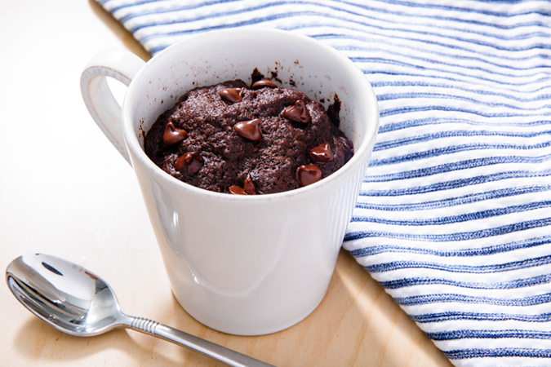Chocolate mug cake can solve your chocolate cravings faster and much easier. When it comes to keto-friendly diet, it is essential to know that carbs are enemies. But, a chocolate market that is completely Keto-friendly can solve your immediate chocolate cravings.

A mug cake can be made quickly without any preparation. It is made just by mixing all the ingredients well. One can add flour, cocoa powder, eggs, Keto-friendly chocolate chips, and sweetener. It is followed by essential baking ingredients or as directed. Make sure you add the perfect amount of measured ingredients in your mug cake to make it more delicious and tasty. You can also add whipped cream for serving.  
Credits: <https://www.delish.com/cooking/g4803/keto-desserts/?slide=31>  
**8. Peanut Butter Cookies  
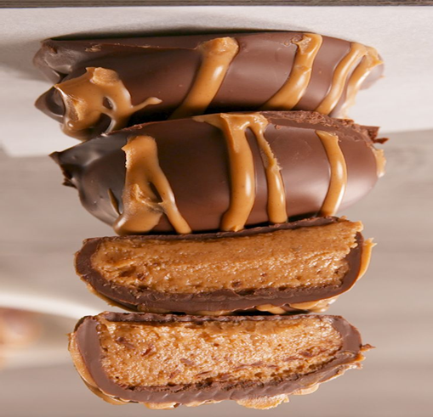**When it comes to home-made cookies, we all know that the smell of cookies can make our mood much better, and we can have it without any guilt. But, if you are on a Keto friendly diet, make sure that making **keto dessert Recipes** are mandatory. There are almost the same ingredients, just like we usually bake it.

Bring peanut butter cookies which are home-made is going to make your day much better. By adding unsweetened peanut butter, coconut flour, keto-friendly sugar, essential baking ingredients, or as directed Make sure that all the ingredients are fresh so that it will make your cookies smell better. After all, who doesn’t love peanut butter cookies?  
Credits: <https://www.delish.com/cooking/g4803/keto-desserts/?slide=31>  
**9. Healthy Avocado Brownies**  
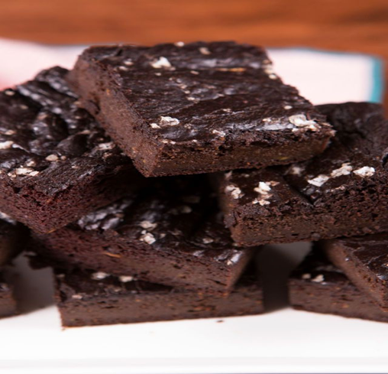  
When it comes to Brownies, we all know that even if we are calorie conscious, we will eat at least a piece of brownie. No matter how hard we tried to ignore the brownie craving, it is not easy to overcome it. But now it is one of the tastiest and recommended **keto Dessert Recipes**. And the smell of baking brownies is making your home utterly mouth-watering. Keto brownies are easy to make. You need to add ripe avocados, unsweetened peanut butter, unsweetened cocoa powder, some eggs, other essential baking ingredients to make your avocado brownie taste like the original one. All the parts are keto-friendly.  
Credits: <https://www.delish.com/cooking/g4803/keto-desserts/?slide=31>  
**10. Chocolate Protein Shake**  
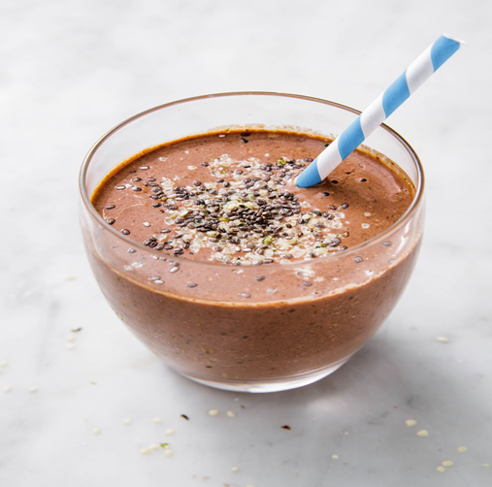  
We all know that protein shake has a weird taste. No matter how hard we try to make a protein shake better, it will never bless our taste buds. But if you are trying **keto Dessert Recipes**, you must try chocolate protein shake, which is entirely keto-friendly. We all know that chocolate is closest to our hearts, even if we try to diet. And going away from chocolate doesn't make sense.

You can add Chia seeds, hemp seeds, almond butter, unsweetened cocoa powder, and keto-friendly sugar to make it one of your most favorite chocolate protein shake. You can have it any time in the day, especially if you are working out, then this will help your mood to get better. This will not only energize you but if you are a chocolate lover, then you can have it as it is. If you want to add fruits in it, you add it too.  
Credits: <https://www.delish.com/cooking/g4803/keto-desserts/?slide=31>  
**11. Mouth Watering Nutella**  
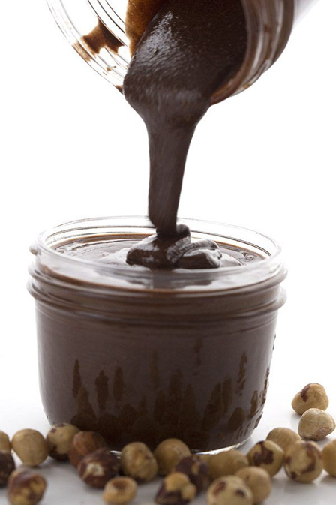  
Nutella is irresistible. And now you can add it as one of your **keto Dessert Recipes**. Nutella is a problem solver for many people out there. When it comes it dessert cravings, we all know it is Nutella, which can quickly solve our questions effectively. You need to add the right amount of nuts and blended correctly, then add hazelnut oil and some cocoa powder with keto-friendly sweetener. Mix it well, and there you go! Keto Nutella Is easy to make, and you can add it to every dessert you want. This is the most wanted keto dessert Recipe, which no one can deny.  
Credits: <https://www.delish.com/cooking/g4803/keto-desserts/?slide=31>  
Now you can answer your dessert cravings. We all know that it is not accessible to diet when it comes to having dessert cravings; we tend to ignore our health and have it. Sugar is one of the enemies if you are trying to get fit. One should avoid having sweet things if they are on a strict diet. But, these above-mentioned **keto dessert Recipes** are worth trying.

You just cannot miss them baking it. They are easy to make, and ingredients are common in all of the recipes. These **keto dessert Recipes** will make sure that your diet is not disturbed. They all are calorie friendly, but working out will help you to bond with your health much faster. Make sure that you try all the recipes and become an excellent keto-friendly baker